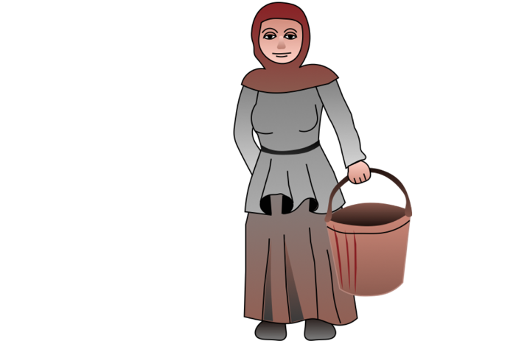**The Feudal System and the Life of Peasants**

**Overview:** This worksheet will give you insight into the lives of the “common people” in Europe in the Middle Ages. You will discover how they fitted into the social structure (and held it up!) and how they lived their lives from day to day.

**Key Vocabulary:**

A **peasant** was a poor farmer who generally lived in poverty. While some peasants were free, many more were in **bondage**. This means that they were almost like slaves, since they belonged to their **lords** and were expected to work for them for about three days a week. This was called **week work**. A peasant in **bondage** was called a **serf** or sometimes a **villein**.

The **feudal system** was a **social structure** or **system** in which some people (for example, the **lords** and **knights**) were wealthier and more powerful than others (for example, the **peasants**). Each group within the society had a certain **role** and was expected to provide protection, miltary service or labour.

**Resources: In order to complete this handout, you will need to visit and study these four links:**

**Link 1:** [**History on the Net – The Feudal System**](https://www.historyonthenet.com/medieval-life-feudalism-feudal-system)

**Link 2:** [**BBC Bitesize – Everyday Life in the Middle Ages**](https://www.bbc.co.uk/bitesize/guides/zm4mn39/revision/6)

**Link 3:** [**Video: The Worst Jobs in History**](https://www.youtube.com/watch?v=VIJlFBAAjvE)

**Link 4:** [**Life on the Manor**](https://year7historygr.edublogs.org/files/2020/03/In-Search-of-History-pp.18-21-Life-on-the-Manor.pdf) (a PDF from an old but excellent textbook)

**Task 1: Fill in a Diagram: The Nature of the Feudal System**

Summarise the feudal system in the diagram below, using the elements provided. See the diagram at **Link 1:** [History on the Net – The Feudal System](https://www.historyonthenet.com/medieval-life-feudalism-feudal-system) to fill in the details below. Two elements are already completed.

lords/barons **•** peasants/villeins **•**  knights **•** ~~king~~ **•** grant(s) land to (x3) **•**

provide grain and labour **•**  provide military service **•** ~~provide knights, money~~

king

provide knights, money

**Task 2: Describe the Feudal System (With Sentence Starters)**

Carefully read the texts about the feudal system at both **Link 1:** [**History on the Net – The Feudal System**](https://www.historyonthenet.com/medieval-life-feudalism-feudal-system) **and Link 2:** [**BBC Bitesize – Everyday Life in the Middle Ages**](https://www.bbc.co.uk/bitesize/guides/zm4mn39/revision/6). Now write your own **description of the feudal system**, using these sentence starters to help you. Proofread your text and don’t forget to punctuate.

• The feudal system was a hierarchy in which…

• Each group in the society is ranked according to…

• The role of the lords/knights/peasants was to…

Type here…

**Task 3: Complete a Fill-the-Blanks Text on the Everyday Life of Peasants**

Read once more through the text at **Link 2:** [**BBC Bitesize – Everyday Life in the Middle Ages**](https://www.bbc.co.uk/bitesize/guides/zm4mn39/revision/6). Fill in the details below, using the words provided. You will have to piece together some of the details yourself.

**Gap-Fillers for the Text Below:** back-breaking **•** daub **•** dawn **•** hard **•** harvesting **•**  honey **•** one-third **•** potatoes **•** ploughing **•** sowing **•**  tomatoes **•** wattle

**a** The work of a medieval peasant was and .

**b** The day’s work began at . The work was based on the seasons, with the

being done in autumn, the in spring and the in August.

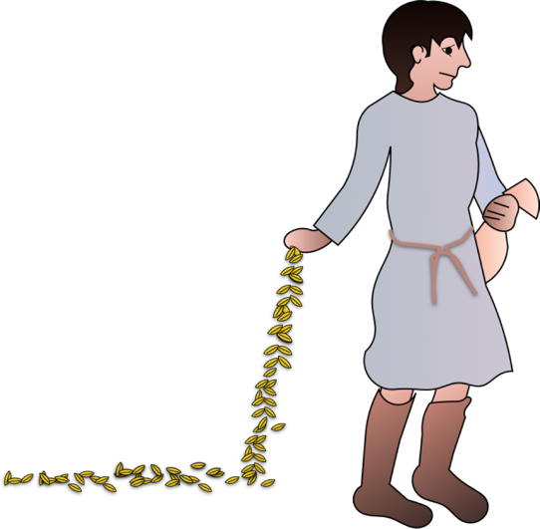**c** Peasant huts were made of , a bendable wooden weaving frame, which was then sealed together with , constructed from straw and animal dung. (Ew!)

**d** About of a peasant’s cottage was used for stabling the animals.

**e** Peasants mainly ate vegetables and rough flat bread. Their vegetables included leeks, carrots and peas – but NOT and . These plant foods are native to the Americas.

**f** was a rare luxury and highly valued for its sweetness.

**Task 4: Create a Set of Notes About Peasant Housing Around the Picture Below**

First read **Link 4:** [**Life on the Manor**](https://year7historygr.edublogs.org/files/2020/03/In-Search-of-History-pp.18-21-Life-on-the-Manor.pdf). On the final page of this text, there is a description of the living conditions in a peasant’s cottage. Add details to **box b** below.

Then watch **Link 3:** [**Video: The Worst Jobs in History**](https://www.youtube.com/watch?v=VIJlFBAAjvE), which details the construction of a typical peasant dwelling. The presenter refers to “churls”, a Saxon word for common farmers. Complete as many details as you can in **boxes c** and **d** to show how peasants built their cottages.

**c** “Wattle” refers to…

The builder had to…

**a** An advantage of this kind of housing was that it was relatively cheap and easy to build and maintain. The materials were widely available and the cottage could be easily repaired.

**Building and Living in a Peasant Cottage**

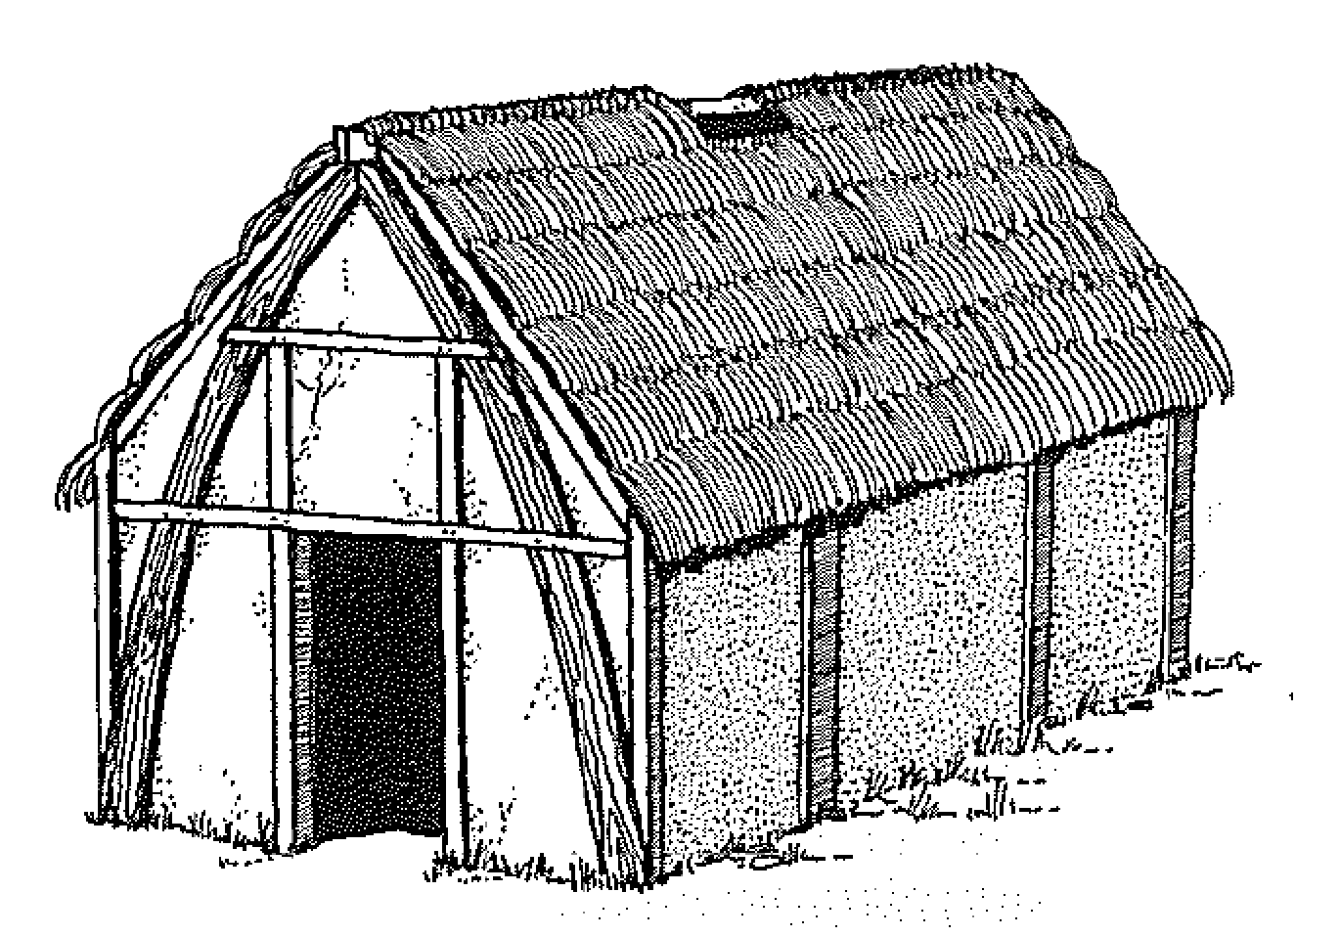

**b** The living conditions in a cottage like this involved many disadvantages, such as:

•

•

•

•

•

•

**d** “Daub” was made of…

The builder had to…