Disease in Human History

Highlight each word or phrase as you hear it in the video.

Diseases | Describing Disease | Factors in Spreading Disease | Effects of the Black Death | Superstitious Fears
bird flu | microscopic organism | growth of population | 1/3 of people living in Europe died | divine will or divine wrath
SARS | bacteria | population density | fall of Yuan dynasty | miasma
HIV/AIDS | micro-parasites | river valleys (stagnant water) | demands for higher wages | Grim Reaper
“Great Dying” | epidemic | domesticated animals | improved working conditions | Medical Advances
smallpox | plague | war | criticisms of religious ideas | inoculation
swine flu | pandemic | trade | new building techniques | antibiotics
Black Death | pestilential disasters/  pestilence | Silk Road | Effects of Other Diseases
bubonic plague
pneumonic plague | 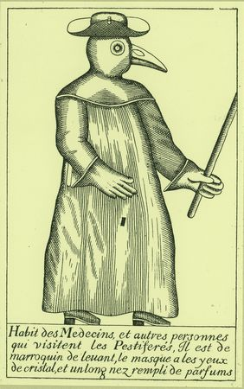 | caravan routes | death of indigenous peoples
“Columbian Exchange” |  | trading ships
syphilis |  |  | European dominance
tuberculosis |  |  | shaping human history
cholera
flu

Cause and Effect Sentences
Use these gap-fillers to complete the sentences below:

Church • density • domesticated • dynasty • indigenous • population • shaping • trade

a The growth of human _______________ was a factor in the spread of disease.
type here…
b When people live in crowded conditions (with high population ___________), this contributes to the spread of disease.
type here…
c One possible effect of the plague was the fall of the Yuan __________ in China.
type here…
d A possible result of the death of at least one-third of Europe’s population was that people began to question the ____________’s ideas and practices.
type here…
e When people _______________ animals, this led to an increase in disease.
type here…
f The explorations and conquests of many Europeans led to the exposure of many ____________ peoples to smallpox and other European diseases.
type here…
type here…
g According to the presenter, John Green, both war and ___________ are factors in the spread of disease.
type here…
h John Green argues that disease plays a role in _______________ human history.

